Computer Graphics Course –

Exercise 2: 2D Transformations

Danit Noa Yechezkel – 203964036

Dekel Menashe – 311224117

Keren Halpert – 313604621

Logical Data Format:

The file consists of a series of lines that provide coordinates to one of three graphical objects: Line, Curve, Circle.

The line is defined by 4 values: x1, y1, x2, y2.

The curve is defined by 8 values: x1, y1, x2, y2, x3, y3, x4, y4.

The circle is defined by 3 values: x1, y1, r (radius).

Example:

line  
curve  
circle

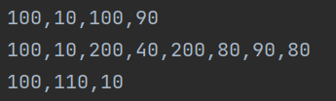

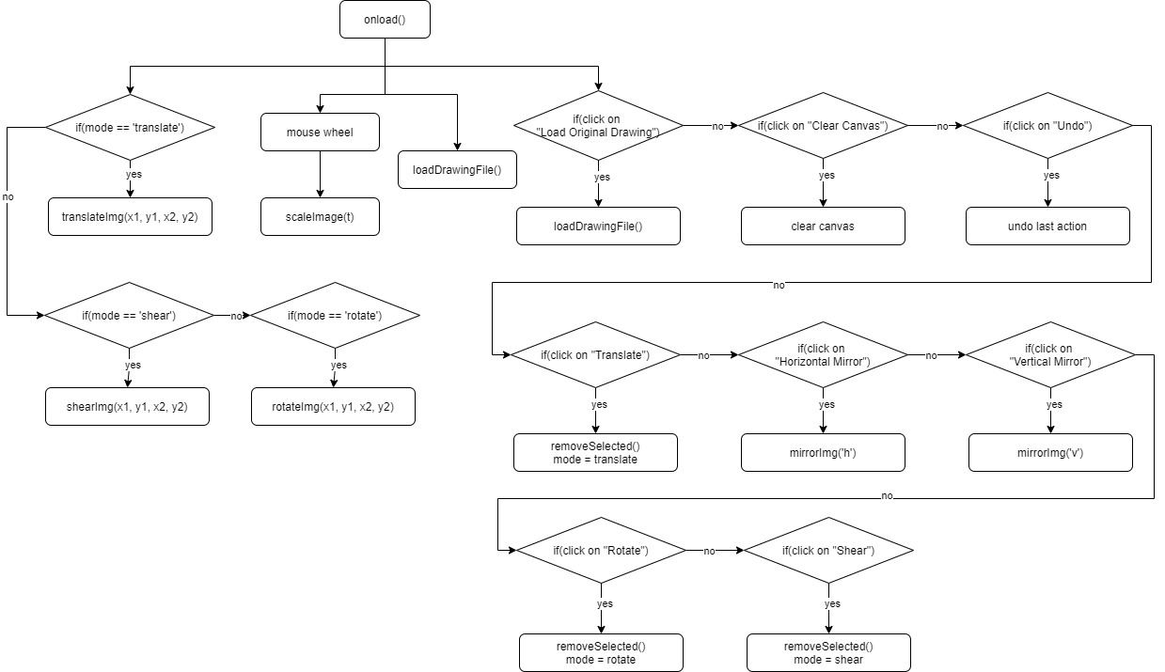Function Flow:

Exceptions:

There are help messages in the GUI.

The input for the program is by mouse events therefore the user can’t make an error by inserting an incorrect value. Also – the mouse events work only in the canvas area.

Using mouse events (drag and wheel) the program is more intuitive and lets the user have more control, so no mistakes are made.

The buttons denoting the mode (translate/ rotate/ shear) appear as selected in an attempt to prevent errors by the user, only one mode is “selected” at a time.

On the “Clear Canvas” button, there is a dialog popup to ensure that the user truly wants to clear the canvas.